Drs O’Connell Bradley Bradley Wilkie & Thake
54 Holme Lane Telephone 0114 2343418
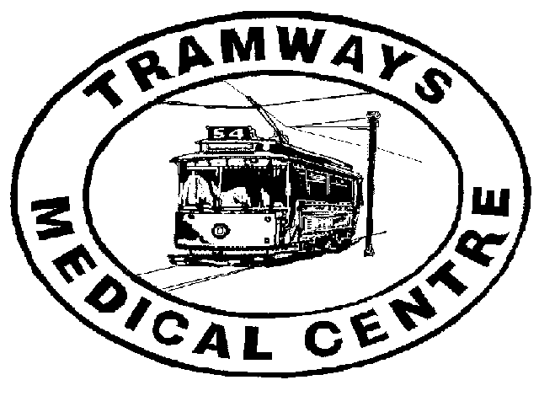
Sheffield
S6 4JQ

How we use your personal information

This Privacy Notice explains why your GP practice collects information about you and how that information may be used.

Health care professionals who provide you with care maintain records about your health and any treatment or care you have received previously (e.g. NHS Trust, GP Surgery, Walk-in clinic, etc.). These records are used to help to provide you with the best possible healthcare.
NHS health care records may be electronic, on paper or a mixture of both, and we use a combination of working practices and technology to ensure that your information is kept confidential and secure.

Records this GP Practice hold about you may include the following information:
• Details about you, such as your name, address, carers, legal representatives and emergency contact details
• Any contact the surgery has had with you, such as appointments, clinic visits, emergency appointments, etc.
• Notes and reports about your health
• Details about your treatment and care
• Results of investigations such as laboratory tests, x-rays, etc.
• Relevant information from other health professionals, relatives or those who care for you
To ensure you receive the best possible care, your records are used to facilitate the care you receive. Information held about you may be used to help protect the health of the public and to help us manage the NHS. Information may be used within the GP practice for clinical audit to monitor the quality of the service provided.
Some of this information will be held centrally and used for statistical purposes. Where we do this, we take strict measures to ensure that individual patients cannot be identified.
Sometimes your information may be requested to be used for research purposes – the surgery will always gain your consent before releasing the information for this purpose.

Risk Stratification
Risk stratification data tools are increasingly being used in the NHS to help determine a person’s risk of suffering a particular condition, preventing an unplanned or (re)admission and identifying a need for preventive intervention. Information about you is collected from a number of sources including NHS Trusts and from this GP Practice. A risk score is then arrived at through an analysis of your de-identified information and is only provided back to your GP as data controller in an identifiable form. Risk stratification enables your GP to focus on preventing ill health and not just the treatment of sickness. If necessary your GP may be able to offer you additional services.
Please note that you have the right to opt out of your data being used in this way.

Medicines Management
The Practice may conduct Medicines Management Reviews of medications prescribed to its patients. This service performs a review of prescribed medications to ensure patients receive the most appropriate, up to date and cost effective treatments. This service is provided to practices within Sheffield Clinical Commissioning Group.

How do we maintain the confidentiality of your records?
We are committed to protecting your privacy and will only use information collected lawfully in accordance with:
• Data Protection Act 1998 and General Data Protection Regulation 2016
• Human Rights Act 1998
• Common Law Duty of Confidentiality
• Health and Social Care Act 2012
• NHS Codes of Confidentiality, Information Security and Records Management
• Information: To Share or Not to Share Review
Every member of staff who works for an NHS organisation has a legal obligation to keep information about you confidential.
We will only ever use or pass on information about you if others involved in your care have a genuine need for it. We will not disclose your information to any third party without your permission unless there are exceptional circumstances (i.e. life or death situations), where the law requires information to be passed on and / or in accordance with the new information sharing principle following Dame Fiona Caldicott’s information sharing review (Information to share or not to share) where “The duty to share information can be as important as the duty to protect patient confidentiality.” This means that health and social care professionals should have the confidence to share information in the best interests of their patients within the framework set out by the Caldicott principles. They should be supported by the policies of their employers, regulators and professional bodies.

Who are our partner organisations?
We may also have to share your information, subject to strict agreements on how it will be used, with the following organisations:
• NHS Trusts / Foundation Trusts
• GPs
• NHS Commissioning Support Units
• Independent Contractors such as dentists, opticians, pharmacists
• Private Sector Providers
• Voluntary Sector Providers
• Ambulance Trusts
• Clinical Commissioning Groups
• Social Care Services
• Health and Social Care Information Centre (HSCIC)
• Local Authorities
• Education Services
• Fire and Rescue Services
• Police & Judicial Services
• Voluntary Sector Providers
• PCS (Primary Care Sheffield)
• Other ‘data processors’ which you will be informed of
You will be informed who your data will be shared with and in some cases asked for explicit consent for this happen when this is required.
We may also use external companies to process personal information, such as for archiving purposes. These companies are bound by contractual agreements to ensure information is kept confidential and secure.

Access to personal information
You have a right under the Data Protection Act 1998 to request access to view or to obtain copies of what information the surgery holds about you and to have it amended should it be inaccurate. In order to request this, you need to do the following:
• Your request must be made in writing to the GP practice – for information from the hospital you should write direct to them
• There may be a charge to have a printed copy of the information held about you
• We are required to respond to you within 1 month
• You will need to give adequate information (for example full name, address, date of birth, NHS number and details of your request) so that your identity can be verified and your records located

Objections / Complaints
Should you have any concerns about how your information is managed at your GP practice, please contact the GP Practice Manager. If you are still unhappy following a review by the GP practice, you can then complain to the Information Commissioners Office (ICO) via their website (www.ico.gov.uk).
If you are happy for your data to be extracted and used for the purposes described in this privacy notice then you do not need to do anything. If you have any concerns about how your data is shared then please contact the practice.

Change of Details
It is important that you tell the person treating you if any of your details such as your name or address have changed or if any of your details such as date of birth is incorrect in order for this to be amended. You have a responsibility to inform us of any changes so our records are accurate and up to date for you.

Notification
The Data Protection Act 1998 requires organisations to register a notification with the Information Commissioner to describe the purposes for which they process personal and sensitive information.
This information is publicly available on the Information Commissioners Office website www.ico.org.uk
The practice is registered with the Information Commissioners Office (ICO).

Who is the Data Controller?
The Data Controller, responsible for keeping your information secure and confidential is:
Tramways Medical Centre
Partners – Dr J O’Connell, Dr A Bradley, Dr K Bradley, Dr P Wilkie, Dr A Thake
Practice Manager – Diane Dickinson
Complaints
Should you have any concerns about how your information is managed by the Practice please contact the Practice Manager at the following address:

Tramways Medical Centre (Dr O’Connell & Partners)
54 Holme lane
Sheffield
S6 4JQ

If you are still unhappy following a review by the Practice you can then complain to the Information Commissioners Office (ICO). www.ico.org.uk, casework@ico.org.uk, telephone: 0303 123 1113 (local rate) or 01625 545 745

